Architecture File Structure

⚛️ FRONTEND (REACT) STRUCTURE
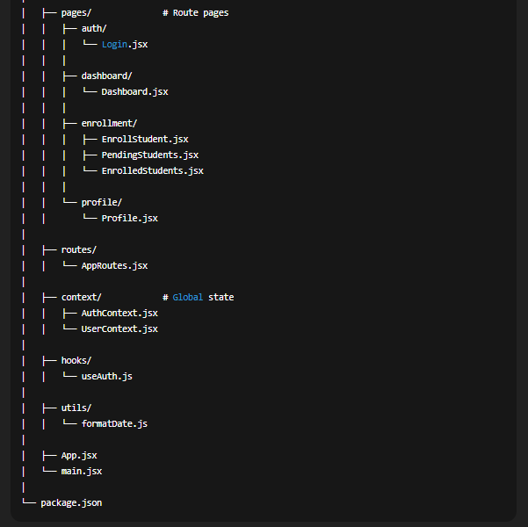
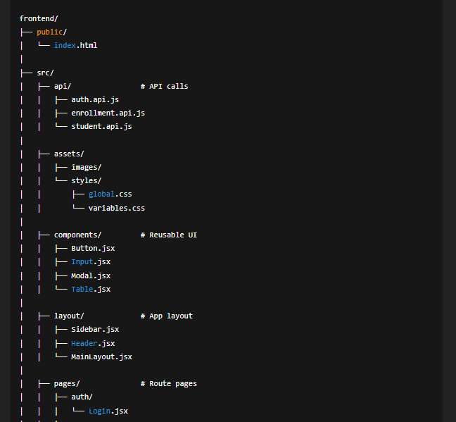

🐘 BACKEND (PHP API) STRUCTURE
